The VaR

**What is VaR**

The VaR gives a measure of the risk of a portfolio on a specific time horizon and for a specific confident level. It basically stand for the amount of loss that a given portfolio will not exceed over this period and for this probability.

Mathematically, we define the VaR as such :



In which alpha is the confident level , r the returns of the portfolio

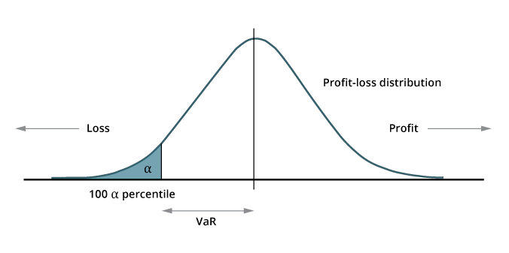

**How do we compute it**

Three different methods can be used to compute the VaR.I will present briefly the two first method then we will focus on the last method, you will find my implementation on github if you want to take a closer look into my work.

**1/The historical method :**

In this method we use the historical datas of the returns of our portfolio over a given time horizon, we sort them and then depending of the confident level « Alpha » the VaR is determined as the Alpha-quantile of this sorted values.

Example :

2/The parametric method :

In this method we assume that our porfolio’s returns are normally distributed, then we are yet to compute its mean and standard deviation and use the VaR formula :





3/The Monte-Carlo method :

**Pros ans cons**

* It gives a rather straight forward and easy to understand way to get an estimate of the risks your portfolio is carrying
* The hypothesis taken on the market are too minimalist therefore a unrealistic
* The Va Ris not additive

<https://meritis.fr/vous-saurez-tout-sur-la-var/>